Purpose:

* Create a database to hold events, users, posts, locations, media, tags, and urls.
* Maintain relationships between entities in a meaningful way
* Allow entities to be inserted from a scraper in a way that is site-agnostic
* Allow entities to be retrieved for user usage

Design:

* Runs on MySQL
  + Likely does not use MySQL specific features, so it may be able to be ported to other SQL databases
    - However, the schema model file is specifically for usage in MySQL workbench
* Uses python3 for all SQL operations
* Above is the relational model used for the database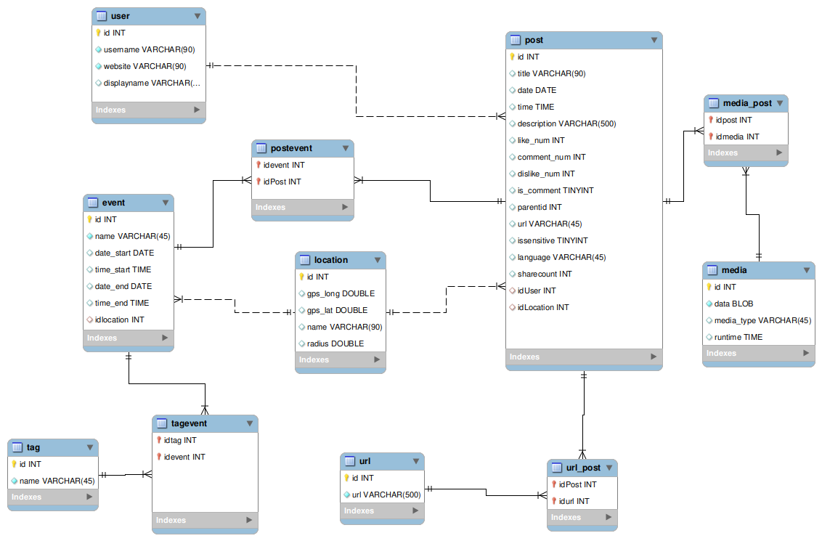

How to use:

* To import the schema into a MySQL database, run the blackswan_create_schema.sql file.
  + WARNING! This script drops existing copies of the schema and tables!
* database_objects.py contains the object-relational mappings needed to interact with the database code.
  + In order to insert entities into the database, they must first be converted into the intermediary object form.
  + In order to receive entities from the database, the program must be able to handle the object form
* inserter.py contains functions for inserting objects or lists of objects into the database
  + Also contains a function to check for duplicate events
* selecter.py contains functions to select entities from the database, returning them as objects

Notes:

* Database stored procedures may be a preferred and more efficient method than the current implementation
* There is a possibility of optimization of select and insert statements in the future, speed is sub-optimal
* Some attributes may need to be indexed to improve performance
* Table compression may save space, particularly in the post table
* Code may need to be written to periodically merge duplicate posts which have all the same attributes and are from the same user from the same website
* The selecter may be able to select locations based on proximity, but has not been implemented
* A media-aware inserter could re-compress media before insertion, saving storage space
* No update statements exist